Year 2005

VCE

Specialist Mathematics

Trial Examination 1

Suggested Solutions

© Kilbaha Multimedia Publishing 2005

 | Kilbaha Multimedia Publishing ABN 47 065 111 373  PO Box 2227  Kew Vic 3101  Australia  Tel: 03 9817 5374  Fax: 03 9817 4334  chemas@chemas.com  www.chemas.com

IMPORTANT COPYRIGHT NOTICE

- This material is copyright. Subject to statutory exception and to the provisions of the relevant collective licensing agreements, no reproduction of any part may take place without the written permission of Kilbaha Multimedia Publishing.
- The contents of this work are copyrighted. Unauthorised copying of any part of this work is illegal and detrimental to the interests of the author.
- For authorised copying within Australia please check that your institution has a licence from Copyright Agency Limited. This permits the copying of small parts of the material, in limited quantities, within the conditions set out in the licence.
- Teachers and students are reminded that for the purposes of school requirements and external assessments, students must submit work that is clearly their own.
- Schools which purchase a licence to use this material may distribute this electronic file to the students at the school for their exclusive use. This distribution can be done either on an Intranet Server or on media for the use on stand-alone computers.
- Schools which purchase a licence to use this material may distribute this printed file to the students at the school for their exclusive use.

- The Word file (if supplied) is for use ONLY within the school

- It may be modified to suit the school syllabus and for teaching purposes.

- All modified versions of the file must carry this copyright notice

- Commercial use of this material is expressly prohibited

ANSWERS TO MULTIPLE CHOICE QUESTIONS

1 | A | B | C | D | E | 16 | A | B | C | D | E
2 | A | B | C | D | E | 17 | A | B | C | D | E
3 | A | B | C | D | E | 18 | A | B | C | D | E
4 | A | B | C | D | E | 19 | A | B | C | D | E
5 | A | B | C | D | E | 20 | A | B | C | D | E
6 | A | B | C | D | E | 21 | A | B | C | D | E
7 | A | B | C | D | E | 22 | A | B | C | D | E
8 | A | B | C | D | E | 23 | A | B | C | D | E
9 | A | B | C | D | E | 24 | A | B | C | D | E
10 | A | B | C | D | E | 25 | A | B | C | D | E
11 | A | B | C | D | E | 26 | A | B | C | D | E
12 | A | B | C | D | E | 27 | A | B | C | D | E
13 | A | B | C | D | E | 28 | A | B | C | D | E
14 | A | B | C | D | E | 29 | A | B | C | D | E
15 | A | B | C | D | E | 30 | A | B | C | D | E

Question 1

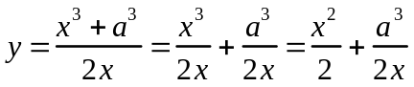 since 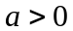
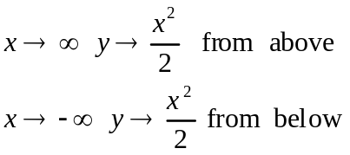
so 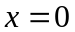 and 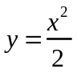are its asymptotes
Answer E.
Question 2
The graph has the equation of the form 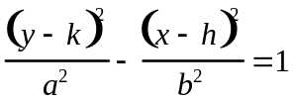
where the centre is 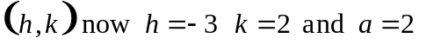the distance from the vertices to the centre. The asymptotes are 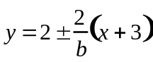, for this to pass through the origin 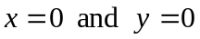 we require 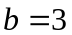, the correct equation is

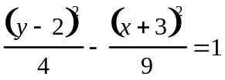
Answer B.
Question 3
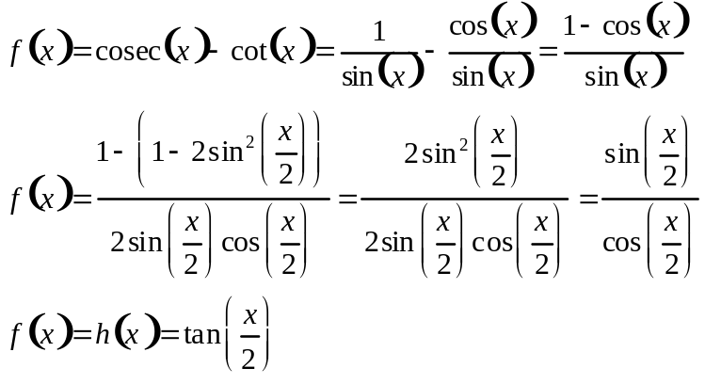
Note that 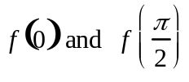 are both not defined
f has range 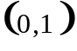 and is identical to the function 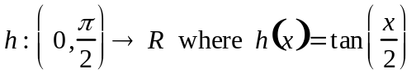
Answer C.
Question 4
The maximal implied domain of 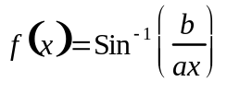
we require
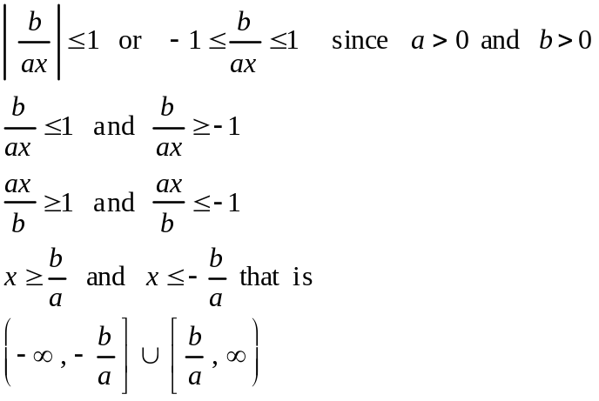
Answer D.

Question 5

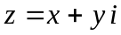 and 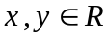 the conjugate 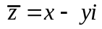 checking each alternative
A. 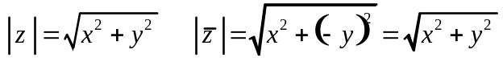 so A. is true
B. 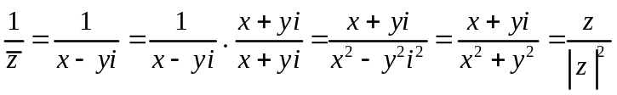 so B. is true
C. 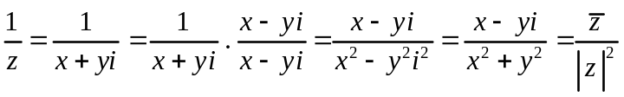
so 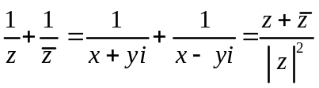 C. is true
D. 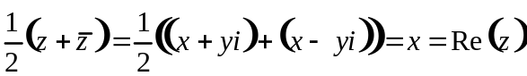 D. is true
E. 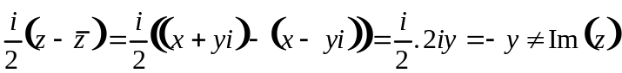 E. is false
Answer E.

Question 6
Let 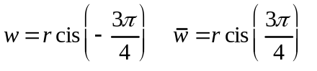 is the point R reflection in the real axis
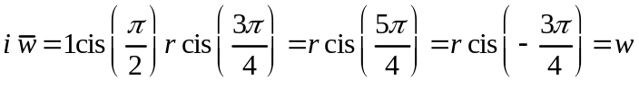 or after another rotation of 90º anticlockwise, we are back at the point W
Answer A.
Question 7
If 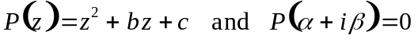 where b , c, 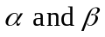 are all real non-zero numbers, then checking each alternative
A. by the conjugate root theorem 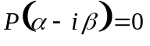 so A. is true
B. Since 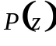 has complex roots the discriminant
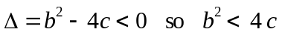 B. is true
C. let 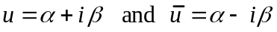 be the roots 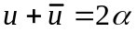 and 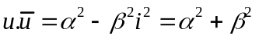 the quadratic is 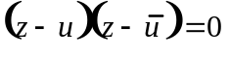
expanding gives
C. is true,
E. has one pair of complex conjugates as its roots, is true
D. is false, the correct statement is 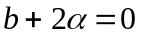
Answer D.
Question 8
A. is false as it does not include the origin, all of B. C. D. and E are true they all give 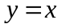 which is the line S as shown.
Answer A.
Question 9
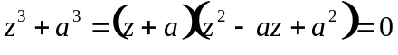 since 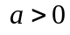 there is one real answer this is the point G, however there are three real roots and furthermore the roots must be equally spaced around the circle by 120º, so the roots are G , C and K
Answer C.
Question 10

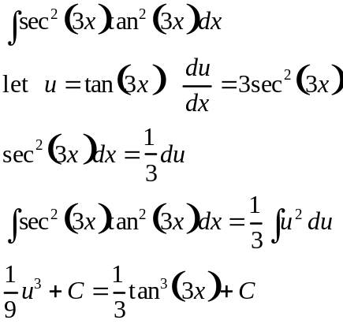
However since an antiderivative is asked for , ignore the C answer 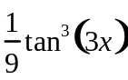
Answer D.
Question 11

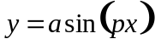 the period is 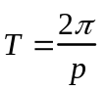 so one-half cycle is the first x-intercept 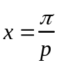
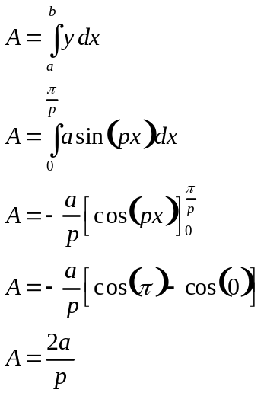
Answer A.
Question 12
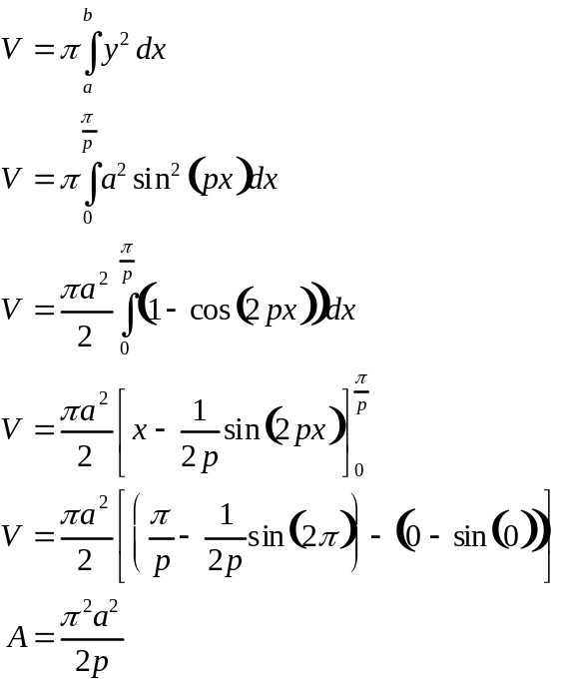
Answer E.
Question 13
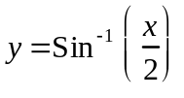at the point where 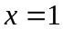 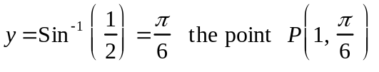

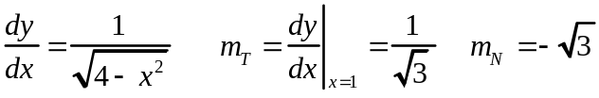 the equation of the normal is
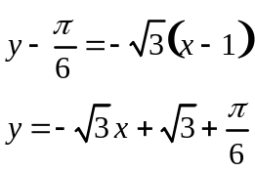
Answer C.

Question 14

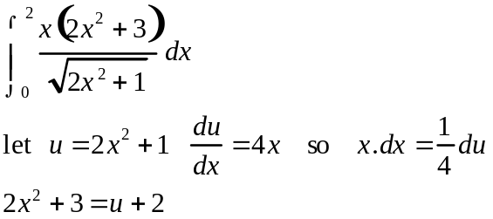
change the teminals when 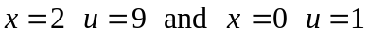
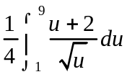 is correct
Answer C.
Question 15
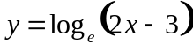
x | 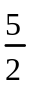 | 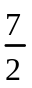 | 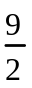
y | 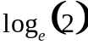 | 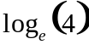 | 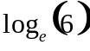

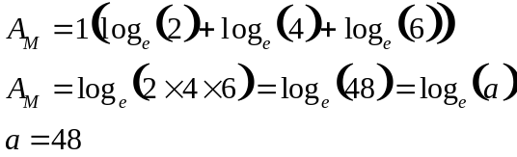
Answer A.

Question 16
Using Euler’s method with 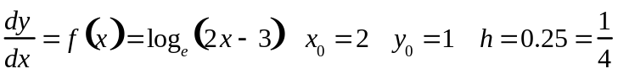
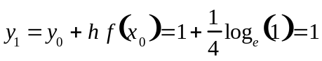
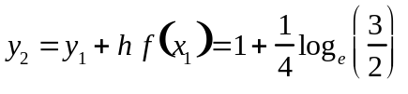
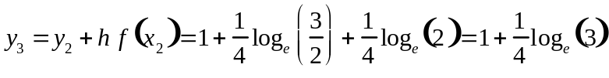
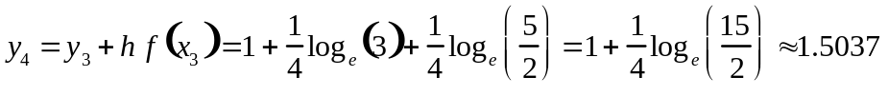
Or use TI-83 programs
Answer D.
Question 17
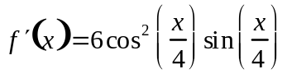 and 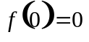
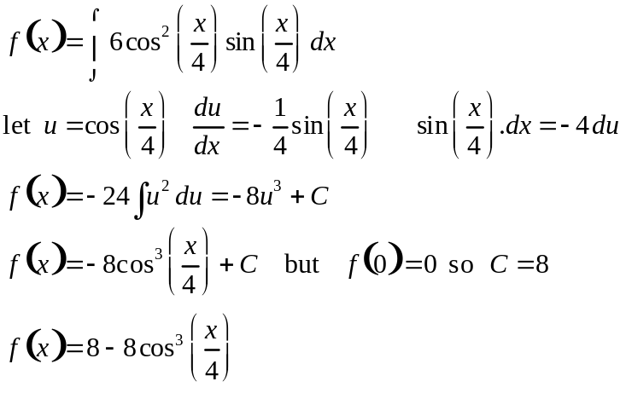
Answer C.
Question 18
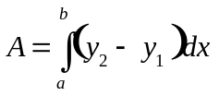
let 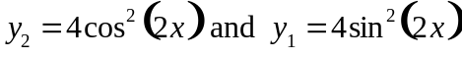
by symmetry, the total shaded area is equal to
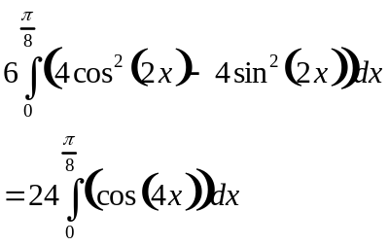
Answer B.
Question 19

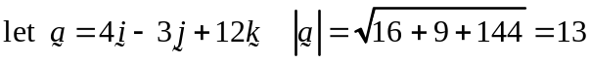
so 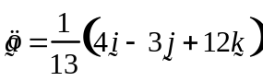
we require
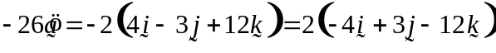

Answer D.

Question 20
let 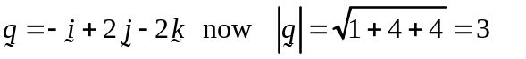
so 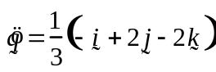
the scalar resolute of in the direction of is 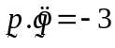
the vector resolute of perpendicular is 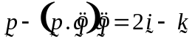
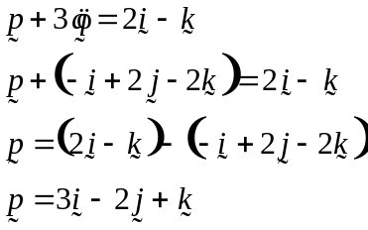

Answer B.

Question 21
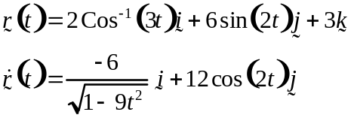
The initial direction of the motion of the particle is 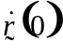
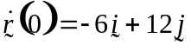

Answer D.
Question 22
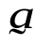
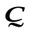
O
A
B
C
A. is true 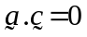 the vectors are perpendicular ( it is a square )
B. is true 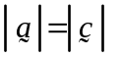the lengths are equal ( it is a square )
C. is true 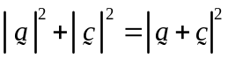 Pythagorus’s Theorem on the diagonal 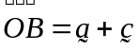
D. is true 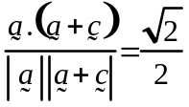 the angle between 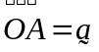 and is 45⁰
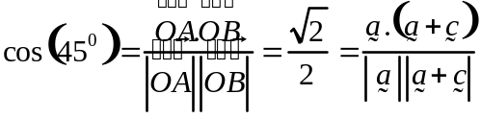
E. is false, for vectors 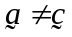
Answer E.

Question 23
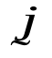
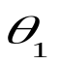
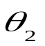
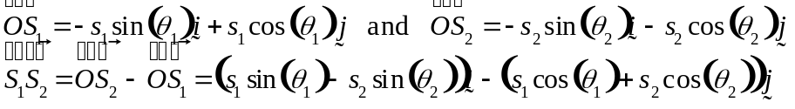
E
S
N
W
S₁
S₂
s₂
s₁
Answer A.

Question 24
A. is true, the particle moves on a circle.
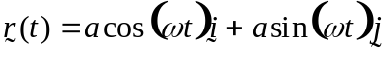
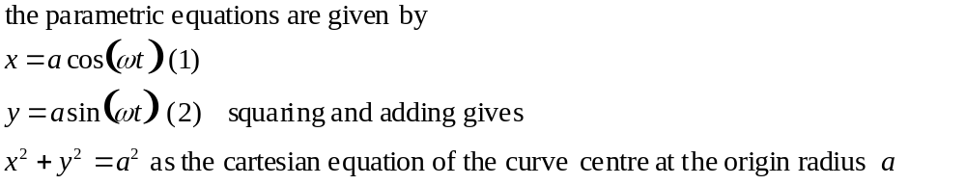
B. is true, the speed of the particle is constant.
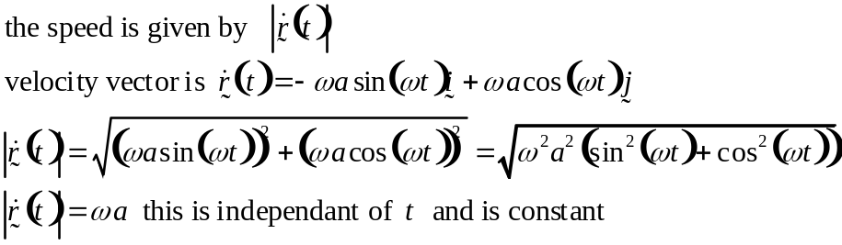
C. is true,
the acceleration vector is in the opposite direction to the position vector.
D. is true, the velocity vector is perpendicular to the position vector.
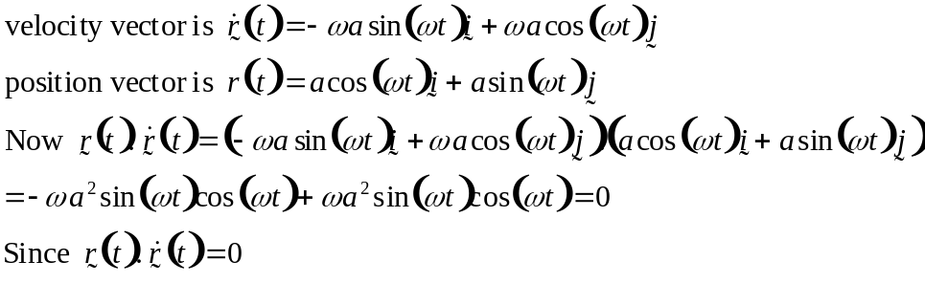
E. Is false, the acceleration vector is not constant.
Answer E.
Question 25

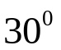
12g

N
P

μN

resolving parallel to the plane 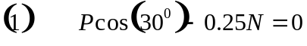
resolving perpendicular to the plane 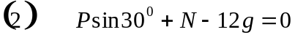
from 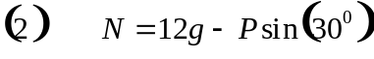 substituting into 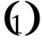 gives
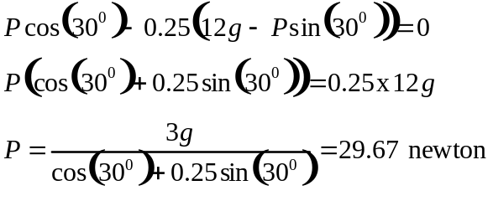
Answer B.
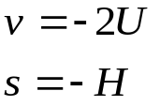
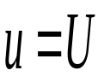
Question 26
H

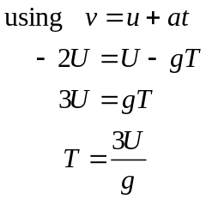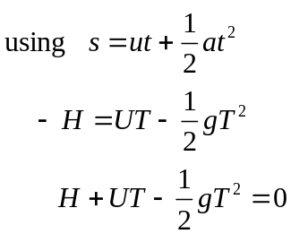
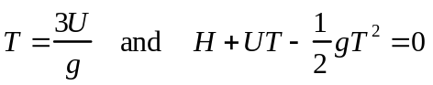
Answer A.

Question 27
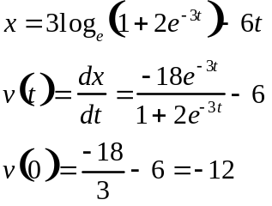
Answer D.

Question 28
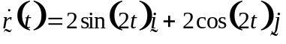 integrating
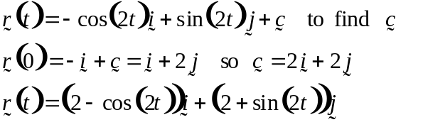
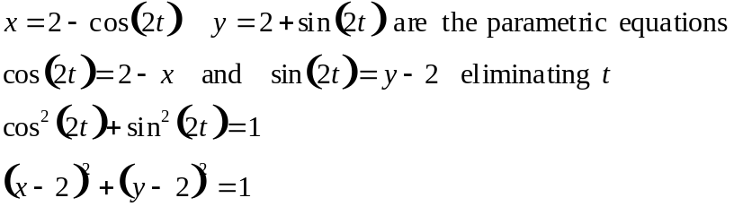
The particle moves on a circle with centre at 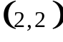 and radius 1
Answer A.

Question 29
2mg
T
T
mg
N
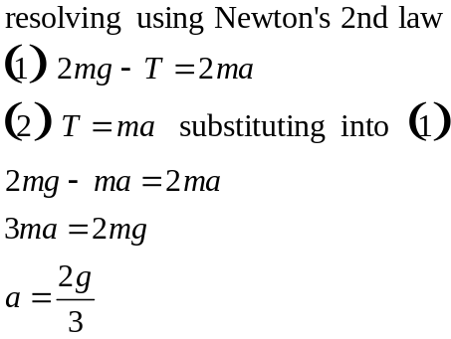

Answer B.
Question 30
All of A. B. C. and D. are incorrect, they all use constant acceleration formulae, when the acceleration is not constant 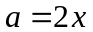
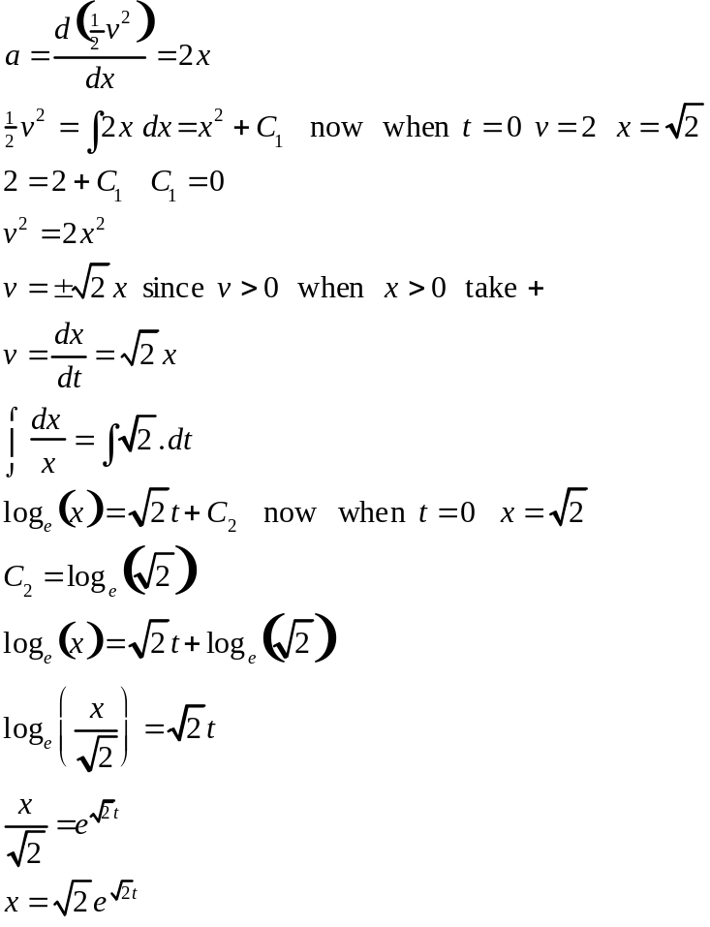
Answer E.
Question 1

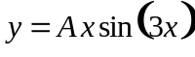 differentiating using the product rule gives
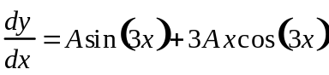differentiating again using the product rule on the last term
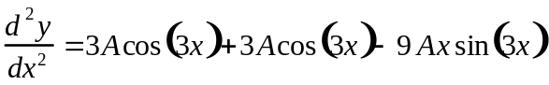
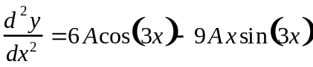 substituting
so that 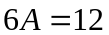
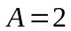
2 marks
Question 2
a. Let 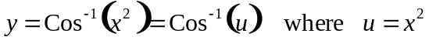
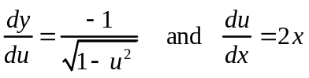 using the Chain Rule
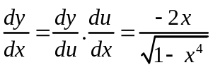
2 marks
b. Since 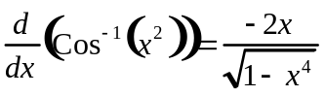 it follows that
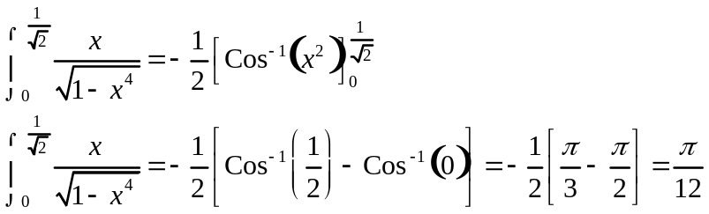
2 marks
Question 3

a. 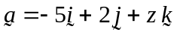 the length of is 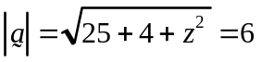
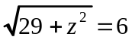 squaring both sides gives
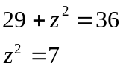
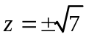 and both answers are acceptable.
2 marks
b. The vector makes an angle of 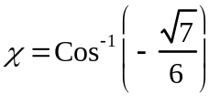 with the z-axis
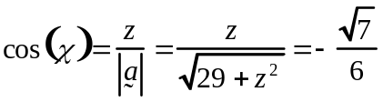
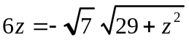 squaring both sides gives
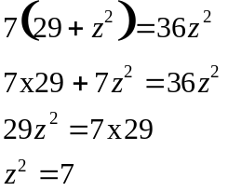
however since the angle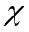 is obtuse we require 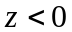
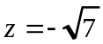 is the only answer.

2 marks

Question 4

a. 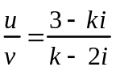 multiplying by the conjugate of v
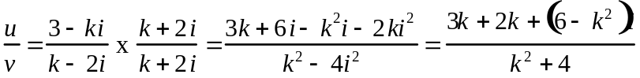
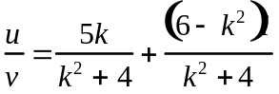 if 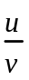 is real we require the imaginary part to be zero
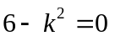 so that
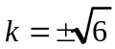
2 marks

b. 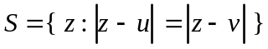 substituting for u and v gives
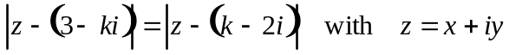
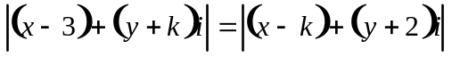 from the definition
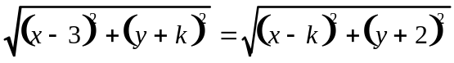 squaring and expanding both sides
simplifying
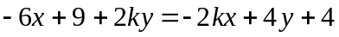
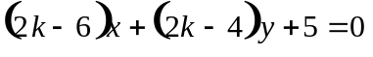 comparing this with T
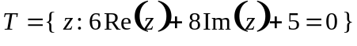 since 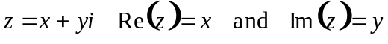 it follows that
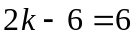 and 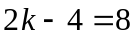 so that
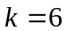
2 marks
Question 5

a. Let T be the tensions in the strings, by the symmetry both tension are equal.
The reaction of the hook is the normal which is equal and opposite to the weight force of the painting. The situation is

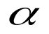
5g
T
T
since 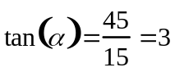 from Pythagorus 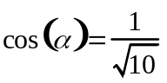
resolving vertically gives

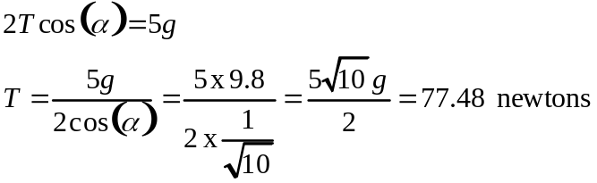
2 marks

b.
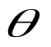
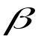
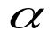
1 metre
painting
x metres
1.5 m
0.5 m
eye level
In the diagram let 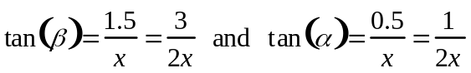 and 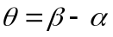
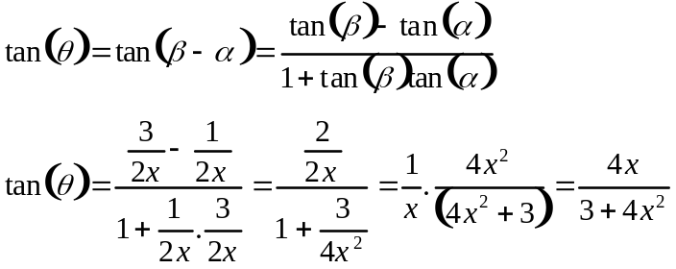
1 mark
c. For maximum viewing angle 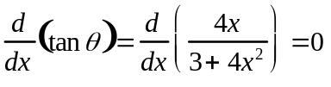
differentiating using the quotient rule
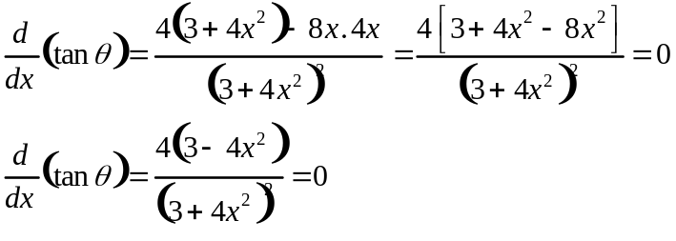
so 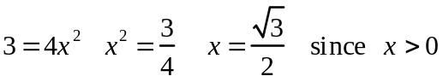
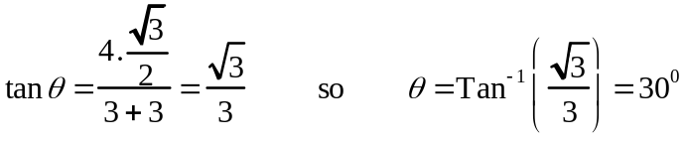
3 marks

End of 2005 Specialist Mathematics Trial Examination 1 Solutions
KILBAHA MULTIMEDIA PUBLISHING  PO BOX 2227  KEW VIC 3101  AUSTRALIA | TEL: (03) 9817 5374  FAX: (03) 9817 4334  chemas@chemas.com  www.chemas.com

